NT-200

2-jaw through-hole power chuck (adapter excluded)
- All sliding surfaces are hardened and ground for accurate actual running and long service repeatability. Lubrication nipple in each base jaw.
- Base jaw : 1.5mm x 60° serration.
- Mounting : Adaptor mounting to fit with DIN, ISO, BS, ASA B5.9 type A spindles.
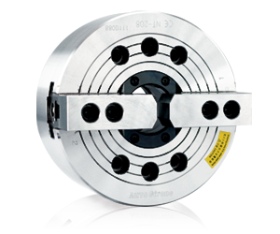
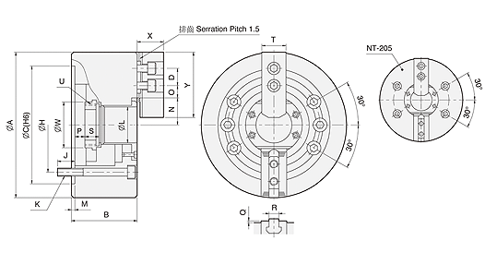
UNIT : mm
SPEC  Model | Through  -Hole  (mm) | Plunger  Stroke  (mm) | Jaw  Stroke  (In Dia.)  (mm) | Max.  Pull  Force  (kgf) | Max.  Gripping  Force  (kgf) | Max.  Operating  Pressure  (kgf / cm²) | Max.  Speed  (r.p.m.) | Weight  (kg) | Moment  Of Inertia  I  (kg‧m² ) | Matching  Cylinder | Matching  Hard Jaw | Matching  Soft Jaw | Gripping  O.D. Range  (mm)
NT-205 | Ø33 | 10 | 5.4 | 1189 | 2447 | 19.5 | 7000 | 6.8 | 0.017 | M1036 | HJ05 | HC05 | Ø6-Ø135
NT-206 | Ø45 | 12 | 5.5 | 1495 | 3875 | 18.9 | 6000 | 12.8 | 0.054 | M1246 | HJ06 | HC06 | Ø15-Ø169
NT-208 | Ø52 | 16 | 7.4 | 2366 | 5975 | 18.4 | 5000 | 22 | 0.163 | M1552 | HJ08 | HC08 | Ø20-Ø210
NT-210 | Ø75 | 19 | 8.8 | 2927 | 7546 | 18.4 | 4200 | 34 | 0.306 | M1875 | HJ10 | HC10 | Ø25-Ø254
NT-212 | Ø91 | 23 | 10.6 | 3875 | 9993 | 18.4 | 3300 | 55 | 0.717 | M2091 | HJ12 | HC12 | Ø30-Ø304
NT-215 | Ø117.5 | 23 | 10.6 | 4823 | 12236 | 15.3 | 2500 | 106 | 2.17 | M2511 | HJ15 | HC15 | Ø50-Ø381
NT-218 | Ø117.5 | 23 | 10.6 | 4823 | 12236 | 15.3 | 2000 | 122 | 3.31 | M2511 | HJ15 | HC15 | Ø50-Ø450

DIM  Model | A | B | C  (H6) | D | H | J | K | L | M | N  max. | O  max. | O  min. | P  max. | P  min. | Q | R | S | T | U  max. | W | X | Y
NT-205 | 135 | 60 | 110 | 14 | 82.55 | 15 | 4-M10x60 | 33 | 4 | 23.2 | 26.5 | 7.75 | 1 | -9 | 2 | 10 | 20 | 23 | M40x1.5 | 45 | 31 | 54
NT-206 | 169 | 81 | 140 | 20 | 104.78 | 16 | 6-M10x80 | 45 | 5 | 26.5 | 32 | 9.25 | 11 | -1 | 2 | 12 | 19 | 31 | M55x2 | 60 | 37 | 73
NT-208 | 210 | 91 | 170 | 25 | 133.35 | 20 | 6-M12x90 | 52 | 5 | 32 | 38.7 | 11.75 | 14.5 | -1.5 | 2 | 14 | 20.5 | 35 | M60x2 | 66 | 38 | 95
NT-210 | 254 | 100 | 220 | 30 | 171.45 | 22 | 6-M16x100 | 75 | 5 | 38.7 | 51 | 14.25 | 8.5 | -10.5 | 2 | 16 | 25 | 40 | M85x2 | 94 | 43 | 110
NT-212 | 304 | 110 | 220 | 30 | 171.45 | 23 | 6-M16x110 | 91 | 6 | 51 | 61.3 | 15.75 | 8 | -15 | 2 | 21 | 28 | 50 | M100x2 | 108 | 51 | 130
NT-215 | 381 | 133 | 300 | 43 | 235 | 35 | 6-M20x135 | 117.5 | 6 | 61.3 | 82 | 15.25 | 7 | -16 | 5 | 22 | 43 | 62 | M130x2 | 139 | 66 | 165
NT-218 | 450 | 133 | 300 | 43 | 235 | 35 | 6-M20x135 | 117.5 | 6 | 82 | 82 | 15.25 | 7 | -16 | 5 | 22 | 43 | 62 | M130x2 | 139 | 66 | 165

